Assignment Report
Distributed Computing
Name: Rishindra Mateti UID: - U01122471
PART II
Multithreading Example
Objective: -The objective of this assignment is to implement thread synchronization using the lock keyword and compare sequential vs. parallel matrix multiplication in C#. It aims to ensure thread safety while incrementing a shared counter and analyze the performance benefits of parallel execution using Parallel.For. This helps in understanding race conditions, synchronization, and efficient computation in multi-threaded applications.
Steps to Execute: -
1. Design the User Interface (Form1.cs Design)S
- A Windows Form was created with three buttons:
- Start Computation: Triggers a long computation in a separate thread.
- Get Temperature: Fetches the latest temperature updated by a background thread.
- Get Stock Price: Fetches the latest stock price updated by a separate thread.
- Each button was linked to the corresponding click event handlers in code

2. Creating a Class (LongOperations.cs)
A class named LongOperations was created to encapsulate the multithreading logic.
It includes the method for
- Simulating a long computation (Compute)
- Continuously updating temperature values (GetWeather).
- Continuously updating stock prices with controlled termination (GetStockPrice).
3. Implement Logic in Form1.cs
The LongOperations class was instantiated in the form to manage threads and shared data.
Event handlers for button clicks were implemented:
- Start Computation:
private void btnCompute_Click(object sender, EventArgs e)
{
lop.Data = 25; // Example input
thCompute = new Thread(new ThreadStart(lop.Compute));
thCompute.Start();
thCompute.Join(); // Wait for computation to finish
MessageBox.Show($"Computation Result: {lop.Result}");
}
- Get Temperature:

private void btnGetTemperature_Click(object sender, EventArgs e)
{
MessageBox.Show($"Current Temperature: {lop.Temperature}°F");
}

- Get Stock Price:

private void btnGetStockPrice_Click(object sender, EventArgs e)
{
MessageBox.Show($"Current Stock Price: ${lop.StockPrice:F2}");
}
4. Handling Threads on Form Closing
- Ensure proper termination of threads in the FormClosing event:
private void Form1_FormClosing(object sender, FormClosingEventArgs e)
{
lop.Terminate = true; // Signal stock price thread to stop
if (thStock != null && thStock.IsAlive)
thStock.Join(); // Wait for stock price thread to finish

if (thCompute != null && thCompute.IsAlive)
thCompute.Join(); // Wait for computation thread to finish
}
5. Thread Initialization :
- Threads are initialized in the Form1_Load method:
private void Form1_Load(object sender, EventArgs e)
{
lop = new LongOperations();

// Start background thread for weather updates
thWeather = new Thread(new ThreadStart(lop.GetWeather))
{
IsBackground = true
};
thWeather.Start();

// Start stock price update thread
thStock = new Thread(new ThreadStart(lop.GetStockPrice));
thStock.Start();
}
Results :
- Start Computation
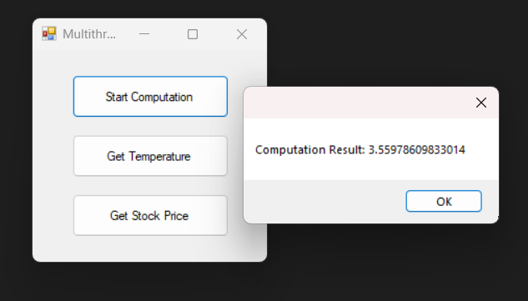

- Get Temperature
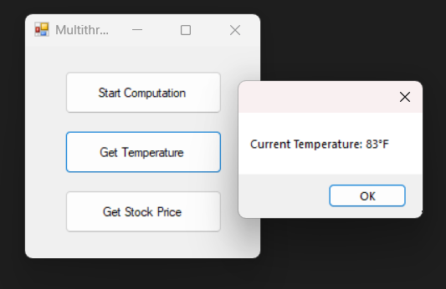

- Get Stock Price
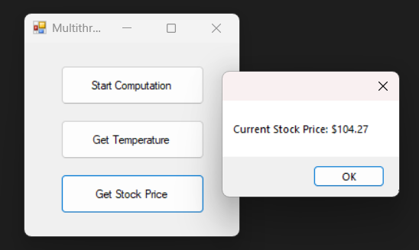

Challenges Faced:
- Initially, race conditions occurred when multiple threads accessed shared resources. This was resolved using lock statements to ensure thread-safe access to shared variables like stockPrice, temperature, and result.
- Ensuring the termination of the stock price thread was tricky. This was solved by introducing a Terminate flag to gracefully stop the thread during application closure.
- The UI would hang when handling long computations if the main thread was blocked. Using a separate thread for computation and invoking. Join() resolved this issue.

Lessons Learned :
- Thread Safety: Proper synchronization mechanisms like lock are critical for accessing shared resources in multithreaded programs.
- Background Threads: Using background threads ensures smooth application termination when no critical data is being handled.
- Controlled Termination: Long-running threads must be terminated properly to avoid hanging processes, especially when dealing with critical updates.

Conclusion: This assignment demonstrated the practical implementation of multithreading concepts using C#. The program successfully managed multiple threads, ensured thread safety, and maintained UI responsiveness. Challenges like race conditions and thread termination were addressed effectively, resulting in a robust and functional application.

